

**زانكۆی سه‌لاحه‌دين - هه‌ولێر**

**Salahaddin University - Erbil**

**Salahaddin University   
Learning Management System**

Research project

Submitted to the department of (Computer Science & IT) in partial fulfillment of the requirements for the degree of BSc. (Salahaddin University Learning Management System)

***Prepared By:***

***Malak Kamaran***

***Zina Mazin***

***Supervised By:***

***Mr. Shakhawan Hussein Mahmood***

**May-2020**

**Dedicated to:**

Our parents who are supporting us during this year, and to our supervisor Mr. Shakhawan Hussein Mahmood who helped us to complete this project.

**Certificate**

I certify that the project titled “***Salahaddin University   
Learning Management System***" was done under my supervision at the Computer Science and IT Department, College of Science - Salahaddin University –Erbil. In the partial fulfillment of the requirements for the degree of Bachelor of Computer Science and IT.

**Supervisor**

**Signature:**

Name: Mr. Shakhawan Hussein Mahmood

Date: 00/00/2020

**Abstract**

An electronic way of learning and communicating with students offers a lot of advantages that can be achieved through different solutions. Among them, the most popular approach is the use of a learning management system.

As COVID-19 continues spreading in many countries posing a serious threat to our health, security and lives, education in schools and universities is also facing unprecedented challenges. In response to a surge in school and university closures due to spreading the spread of COVID-19 the best way continue education is to use LMS, Which facilitate student learning and interaction during periods of school closure.

In this project we create an LMS website specifically for University of Salahaddin, The project will be a little contribution in the enhancement of Higher Education System in Kurdistan Region towards electronification of the system, LMS provides an easier communication process between lecturers and students in an efficient way at Salahaddin University. The teachers will be able to upload materials and assignments on website and the students can check the assignments and submit them.

In this project we investigate the factors influence the success of LMS and how it affects the enhancement of learning nowadays.

**Table of Contents**

|  |  |
| --- | --- |
| **Chapter** | **Page** |
| Dedication  Certificate  Abstract  **Chapter One**  Introduction  1.1 Overview  1.2 History  1.3 Aim of the project  1.4 Objective of the Project  1.5 Features of learning management system  1.5.1 Ease of use  1.5.2 Accessibility  1.5.3 Security and privacy  1.6 Related Work  1.6.1 Moodle  1.6.2 Edmodo    **Chapter Two**  Methodology  **Chapter Three**  Analysis and Design  **Chapter Four**  Conclusion  References  Appendix  پوختە | Ii  iii  iv  1  1  3  3 |

**Table of Figures**

|  |  |
| --- | --- |
| **Figure** | **Page** |
| Figure 1.  Figure 2. |  |

**Chapter One**

**Introduction**

* 1. **Overview**

Learning management System (LMS) is Web-based application software designed to introduce a helpful and structured information exchange environment for participating students, teachers and the administration of college. This software program systems enable educational establishments to control student-associated activities such as keeping records of tests or examinations conducted, attendance, and all other association related activities; in short, they provide a whole student data system. They are designed with different application abilities reaching from simple management of students’ records at college to management of all student-related functions as well as administrative purposes of a university or a sequence of educational institutions. The Learning Management System goes far beyond conventional training by recording every training session, managing individual training requirements and reporting training progress. Most LMSs are Web-based and facilitate “anytime, anyplace, any pace” access to learning content and administration.

* 1. **History**

The first learning management system was developed in 1924when Sidney pressey invented the first ‘teaching machine’. This resembled a typewriter with a window that could administer questions .One window was used to show the questions and the other one to fill in the answer ,Much of the software used in beyond student information structures and college management worked on a nonoperational code base and had a curio us combination of presentation, enterprise sense, and record accessibility. It was difficult and frequently highly-priced to regulate these structures to provide to future demands.

Some of the early creativity software programs together with WebCT, SCT Campus Pipeline, Jet speed, and Blackboard simply enabled interactions between students and teachers for academic purposes and served only as a student information system. The benefit of having a student management system was disappeared as it was not possible to combine any of the campus-based activities within these systems. Most often, student data were kept distributed in a couple of locations, making it hard to interpret and project.

* 1. **Aim of LMS**

Creating a secured LMS for Salahaddin University under the name “SULMS” which is an online platform where teachers and students can collaborate in order to improve student achievement.

* 1. **Objective of LMS**

The principal goal of Learning Management Systems is to enhance the learning process. A Learning Management System not only provide content, but also handles registering courses, course administration, skill gap analysis, tracking, and reporting. Most LMSs are web primarily based and are used in diverse instructional institutes.

The basic objectives of Salahaddin University LMS are:

1. To create a login page in which user can login to and logout from this page successfully.
2. There will be three user roles that are Admin, Teacher and Student
3. The admin should have access to all parts of the system.
4. The teachers should be able to create courses, create assignments, and upload and download files.
5. The student should be able to view course materials, download files and submit assignments.
   1. **Features of LMS**

**1.5.1 Ease of use**

An LMS must be easy to navigate and customizable to the needs of students.

**1.5.2 Accessibility**

The largest perk of eLearning is that it can be accessed anytime, anywhere. This allows users to learn from home rather than taking up class time. The benefits only reach their full potential if the learning content can be accessed as effectively on a smartphone as on a desktop.

**1.5.3 Security and privacy**

(Mautref,2018)

* 1. **Related work**
     1. **Moodle**

Moodle is the world’s most famous and most used Learning Management System LMS, Because Moodle LMS is a flexible, open source, and free to download learning management solution. With 68 million users and 55,000 Moodle sites deployed worldwide, Moodle is a user-friendly eLearning platform that serves the education and training needs of human being from all types of organizations. (Young ,2018)

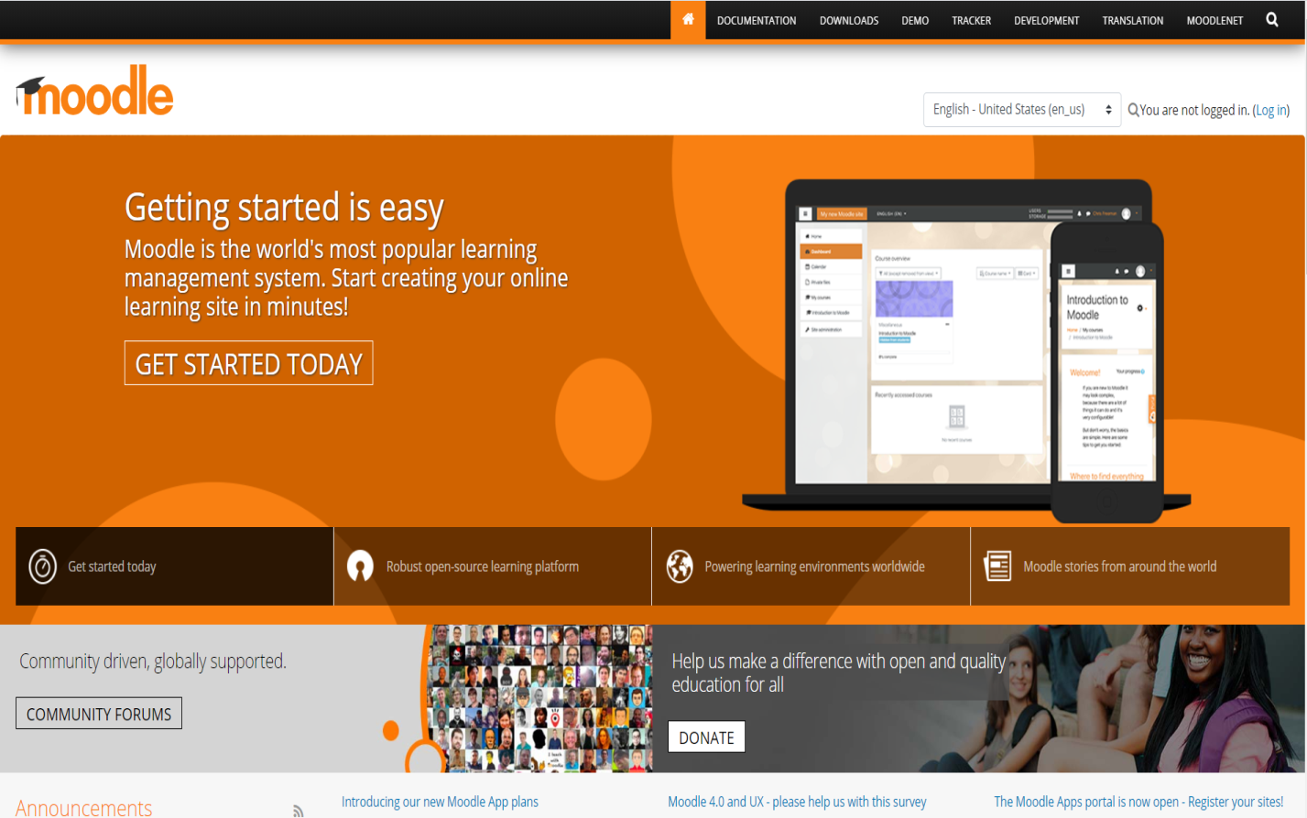**Figure (1.1) home page screen of Moodle**

**The Advantages of Moodle:**

Online studying and continued education opportunities in any place, time and situation.

**Moodle is Supported by a Global Community**

Moodle is supported by using a global community of builders. A large advantage of open source software is that the code is open for scrutiny. This way that developers from all over the world can get right of entry to the code and alter it so that it is more secure. (Young ,2018)

* + 1. **Edmodo**

Edmodo is an educational network which provides teachers with tools to help them connect and communicate with their students and parents. Via the Edmodo app or website, teachers can share content, texts, videos, homework and assignments with their students online.( Blog,2008)

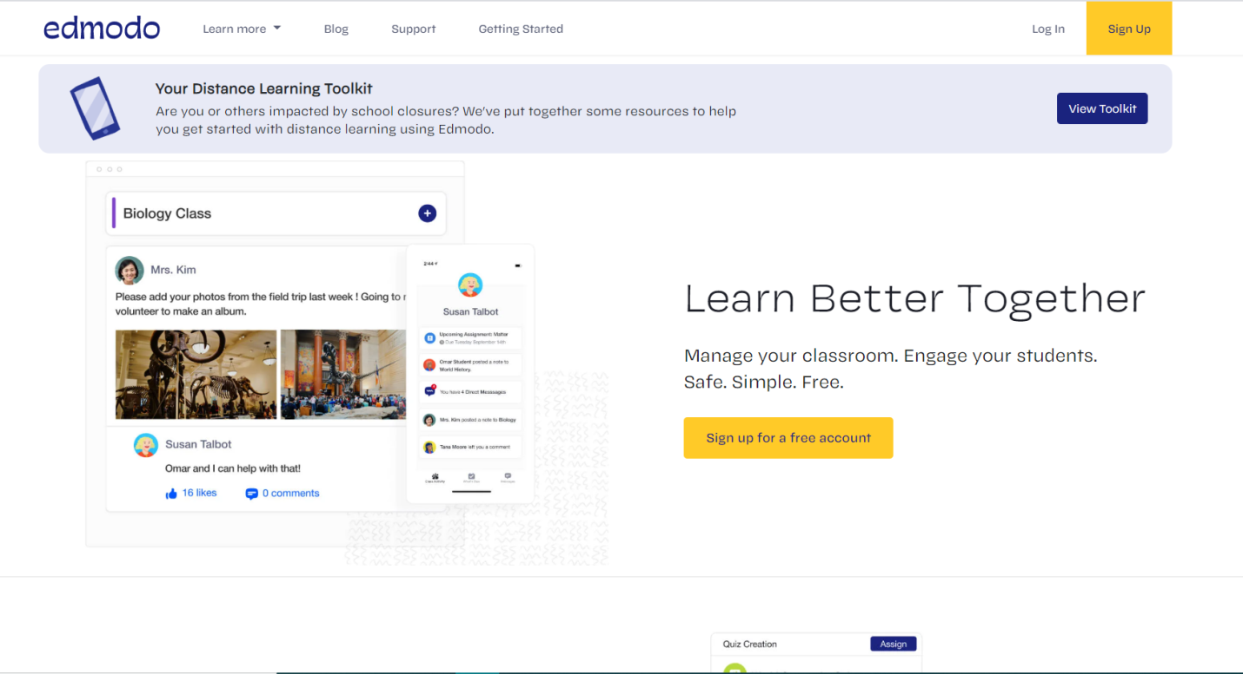

**Figure (1.2) home page screen of Edmodo**

**Advantages of Edmodo**

Edmodo has many features that let students to access class information quickly. Teachers are able to respond online through the site to the students and to their parents.

**Disadvantage of Edmodo**

Edmodo is a social networking internet site. Teachers, students and parents may use the site incorrectly. Another disadvantage is access to the internet. If this site is going to be used for assignments or announcements, all students must have access to the site at home.

* 1. **Advantage of LMS**

• **It’s cheaper**: students can learn with any linked device that is connected to the Internet. There’s no need to rent a building or pay for high-priced utility bills that are required to provide students with a learning facility. In addition, students and teachers will no longer attend to class, and that saves their money as well!

• **Access to course material is at anytime**: Course material is up to date and students can see the changes made in the particular field.

• **It takes much less time**: The teacher doesn’t

need to give the same class repeatedly to different groups of students.

• **It allows for self-paced studying**: Students can take courses from their own devices anytime and anywhere they want.

• **It’s modern**: Most people today prefer to consume content using the Internet.

• It’s a **motivation** to learners, provide feedback and support during the learning process.

**Disadvantage of learning management syatem**

* Keeping in mind that students are using a PC and not being watched at all times, they could potentially copy other essays and other assignments.
* **Cheating**: it can be easier for students to cheat on online exams.
* **Isolation:** Since students are not physically in a classroom, they feel kind of isolation.

**Chapter Two**

**Methodology**

The agile software development methodology was employed in the development process. This is because it allows for visible results quickly and for quick iteration and advancement of the system.

Features of the proposed system are the main login page, the admin login page, teacher login page, student login page, also security, delivery, interaction and record keeping will be put into place. The system will require the user to login to have access to the website to do the following tasks: view and download course materials, upload files, projects and other materials for students**.**

ISSN 2320-9194 6

IJOAR© 2014

http://www.ijoar.org

Major benefits of Moodle are that it is easy to run, administer and maintain due to the fact that it is free.

Despite these amazing benefits, some users are that Moodle relies on third-party add-ons to create

functionality rather than including it as part of the core product. Though Moodle is free to acquire and

use, administration and maintenance costs are often more significant than purchase [9].

Generally, learning management systems incorporate the use of content management and virtual

learning environments. Hence, information can be disseminated to multiple users at the same time via

the internet. A major limitation is that most LMSs do not consider the individual differences of learners.

Recently, increasing attention is paid to characteristics such as learning styles, their impact on learning

and how these individual characteristics can be supported by learning systems [10]. In relation to our own

software, we would incorporate the core features of Sakai, Blackboard and Moodle and optimize them for

use in Babcock University which is our case study.

Methodology

The agile software development methodology was employed in the development process. This is because

it allows for visible results quickly and for quick iteration and advancement of the system [11] [12].

Features of the proposed system are the home page, the administrator login page, lecturer login page,

contact page, help page, register student page, register instructor page, update instructor/student page,

view instructor page and view student page; also security, delivery, interaction, reporting and record

keeping will be put into place. The system will require the user to login to have access to the website to

do the following tasks: view and download course materials, upload files, projects and other materials for

people to see and also interact through live chats and discussion forums. Also the LMS will allow

instructors to upload videos that will be viewed and downloaded. All users will not be allowed to login

simultaneously on multiple systems.

INTERNATIONAL JOURNAL OF ADVANCE RESEARCH, IJOAR .ORG

ISSN 2320-9194 6

IJOAR© 2014

http://www.ijoar.org

Major benefits of Moodle are that it is easy to run, administer and maintain due to the fact that it is free.

Despite these amazing benefits, some users are that Moodle relies on third-party add-ons to create

functionality rather than including it as part of the core product. Though Moodle is free to acquire and

use, administration and maintenance costs are often more significant than purchase [9].

Generally, learning management systems incorporate the use of content management and virtual

learning environments. Hence, information can be disseminated to multiple users at the same time via

the internet. A major limitation is that most LMSs do not consider the individual differences of learners.

Recently, increasing attention is paid to characteristics such as learning styles, their impact on learning

and how these individual characteristics can be supported by learning systems [10]. In relation to our own

software, we would incorporate the core features of Sakai, Blackboard and Moodle and optimize them for

use in Babcock University which is our case study.

Methodology

The agile software development methodology was employed in the development process. This is because

it allows for visible results quickly and for quick iteration and advancement of the system [11] [12].

Features of the proposed system are the home page, the administrator login page, lecturer login page,

contact page, help page, register student page, register instructor page, update instructor/student page,

view instructor page and view student page; also security, delivery, interaction, reporting and record

keeping will be put into place. The system will require the user to login to have access to the website to

do the following tasks: view and download course materials, upload files, projects and other materials for

people to see and also interact through live chats and discussion forums. Also the LMS will allow

instructors to upload videos that will be viewed and downloaded. All users will not be allowed to login

simultaneously on multiple systems.

The agile software development methodology was employed in the development process. This is because

it allows for visible results quickly and for quick iteration and advancement of the system [11] [12].

Features of the proposed system are the home page, the administrator login page, lecturer login page,

contact page, help page, register student page, register instructor page, update instructor/student page,

view instructor page and view student page; also security, delivery, interaction, reporting and record

keeping will be put into place. The system will require the user to login to have access to the website to

do the following tasks: view and download course materials, upload files, projects and other materials for

people to see and also interact through live chats and discussion forums. Also the LMS will allow

instructors to upload videos that will be viewed and downloaded. All users will not be allowed to login

simultaneously on multiple systems.

The agile software development methodology was employed in the development process. This is because

it allows for visible results quickly and for quick iteration and advancement of the system [11] [12].

Features of the proposed system are the home page, the administrator login page, lecturer login page,

contact page, help page, register student page, register instructor page, update instructor/student page,

view instructor page and view student page; also security, delivery, interaction, reporting and record

keeping will be put into place. The system will require the user to login to have access to the website to

do the following tasks: view and download course materials, upload files, projects and other materials for

people to see and also interact through live chats and discussion forums. Also the LMS will allow

instructors to upload videos that will be viewed and downloaded. All users will not be allowed to login

simultaneously on multiple systems.

**2.1 Technical Tools**

**2.1.1 HTML:** is the markuplanguage that we need to implement the structure of our pages and HTML is the latest version .



**Figure (2.1.1) HTML Logo**

**2.1.2 CSS** (Cascading style sheets) : is the styling language that we use it to style the markup language and we use latest version is CSS3, and in our website we use bootstrap 4 which is a CSS framework that make the over CSS work easier to implement .



**Figure (2.1.2) CSS Logo**

**2.1.3 JavaScript:** is the scripting language for web pages and its lightweight and interpreted language that we need it to make dynamic pages , and also its useful to make the process faster as its working on client side . we put some process there which is not necessary to be done in the server side .



**Figure (2.1.3) JavaScript Logo**

**2.1.4 PHP :** Server side programming language that is specially made for web developer and its open source general purpose scripting language, current version . We use it as server side for the main functionality of our project.



**Figure (2.1.4) PHP Logo**

**2.1.5 MYSQL :** is a relation database management language which is open source and free, we use MYSQL as a database management



**Figure (2.1.5) MYSQL Database Logo**

**2.1.6 BOOTSTRAP :**  Bootstrap is a free and open-source “the most popular HTML,CSS,and JS framework for developing.



**Figure (2.1.6) bootstrap Logo**

**2.2 DataBase**

Salahaddin University Learning Management system is done by MYSQL, the data is stored separately in different table and managed by both MYSQL and PHP to provide it on the pages, MYSQL is relation database and the table can have relation by foreign key constraint

**Figure (2.6) Relation of DataBase**

**Chapter Three**

**Analysis and Design**

How the project works with screenshots.

Limitation of the project and future works.

**Chapter Four**

**Conclusion**

E-learning as a teaching-learning mechanism offers opportunities for learning beyond boundaries, by using LMS Teacher can reach to thousands of students easily.

In our project we work on a website called SULMS, its regarded as social networking website for teachers and students. It provides free and secure social learning space for them to connect and collaborate.

The idea behind this LMS is that SULMS is an organized and managed integrated system, it offers file sharing, management of assignment, lesson plans and it facilitate students in submitting their work back to the teacher

**References**

* Anderson,K. (2017) *‘better buys’* Availableat: https://www.betterbuys.com/lms/root-of-all-elearning-lms/?fbclid=IwAR2Diqh3BivMLohevIfjzi9WXopO8bRhJwRLGQN3kkR97oJti21OsIojFz8 (Accessed : 10 may 2020).
* Axmark,D.,Larsson,A. and widenius,M. (1995) ‘*mysql’*  Available at : https://www.google.com/search?q=mysql%20workbench&tbm=isch&source=iu&ictx=1&fir=l9w4VrrlWq9OwM%253A%252CHlsgZVnzw72lcM%252C%252Fm%252F0ffkn6&vet=1&usg=AI4_-kSnIFOGjYs7bflGlDs23piR64LmRA&sa=X&ved=2ahUKEwi9mbDN26zpAhUBMewKHVCyBK0Q_B0wGnoECAkQAw&fbclid=IwAR2TQ4yasz19OSoWUCdkQ1MbrpTgN1najcergkBHWcvrRG7zSmhTjEKkPEA#imgrc=l9w4VrrlWq9OwM [2.1.5] (Accessed : 11 march 2020).
* Berners-lee,T. (1993) *‘html’*  Available at**:** https://www.google.com/search?q=html&bih=616&biw=1034&hl=en-US&tbm=isch&source=iu&ictx=1&fir=Bq4WTYc6O16thM%253A%252C1Ted8cCjatfjsM%252C_&vet=1&usg=AI4_-kTZIdK8U3niZREUK5OIlQNAt7MaMQ&sa=X&ved=2ahUKEwjh1Jv4lqvpAhWRsaQKHZ4RCloQ_h0wAHoECAUQBA#imgrc=Bq4WTYc6O16thM [2.1.1] (Accessed : 11 march 2020).
* Blog,D. (2008) ‘*edmodo’* Available at: https://new.edmodo.com/?go2url=%2F%3F_ga%3D2.185235178.2113100197.1588334088-605468445.1588334088&fbclid=IwAR3_uud-0nzByszZZlsfEws8DfYN90ot0Y2t4c1ky4OaMywtiqU8N-9wYrg [1.2] (Accessed:15 January 2020).
* Dougiamas,M. (2002) *’moodle’ Available* at: https://moodle.org/?fbclid=IwAR3M-tM--TTEHMTicFT5FVmCUp-9g9clvvVt3UU8AkiRQ3oxyWpCfv5wD8o [1.1] (Accessed: 15 January 2020).
* Eich,B. (1995) *‘javascript’*  Available at : https://www.google.com/search?q=javascript&tbm=isch&ved=2ahUKEwi2r7-OrqvpAhUBuKQKHdD-BUIQ2-cCegQIABAA&oq=javascript&gs_lcp=CgNpbWcQA1AAWABg49UCaABwAHgAgAEAiAEAkgEAmAEAqgELZ3dzLXdpei1pbWc&sclient=img&ei=fQi5Xvb8KYHwkgXQ_ZeQBA&bih=616&biw=1034 [2.1.3] (Accessed : 11 march 2020).
* Guler,D. (2018) ‘*eadbox’* Available at : http://en.eadbox.com/moodle-operation-advantages-and-disadvantages-for-distance-education/?fbclid=IwAR2-ctpJvhvj6Ogbn5obDfIqeyhOrWfARruK90ACGWR41u2iYhqf9lkTvm4 (Accessed: 8 april 2020).
* Kats,Y.(2010) *Learning* *management system* technologies and software solution for online teaching[online].available at:https://books.google.iq/books?id=2OsPGIvgjGwC&printsec=frontcover&hl=ar#v=onepage&q&f=false(Accessed:12 January 2020).
* Lerdorf,R. (1994) ‘*php’* Available at *:* https://www.google.com/search?q=php&source=lnms&tbm=isch&sa=X&ved=2ahUKEwi0zoy-r6vpAhUQ_KQKHd3mC-wQ_AUoAXoECBcQAw&biw=1034&bih=616 [2.1.4] *(*Accessed : 11 march 2020).
* Lie,H. (1996) ‘*css’*  Available at : https://www.google.com/search?q=css&source=lnms&tbm=isch&sa=X&ved=2ahUKEwilnt35rKvpAhUE3qQKHe5yBCcQ_AUoAXoECBAQAw&biw=1034&bih=616 [2.1.2] (Accessed : 11 march 2020).
* Mautref,J. (2018) ‘*gutenberg blog’* Available at : https://blog.gutenberg-technology.com/en/10-must-have-features-good-lms?hs_amp=true&fbclid=IwAR0oC5qYazhWLcOuK_F-WxWHybe61GfUsIzcUG5N04UCMBlZ3Pi5ILSCGNw (Accessed at :1 may 2020).
* Otto,M. and Thornton,J. (2011) ‘*bootstrap’* Available at : https://www.google.com/search?q=who+invented+bootstrap&source=lmns&bih=567&biw=1034&hl=en-US&ved=2ahUKEwia78Lmi7fpAhVQlKQKHS_NCqwQ_AUoAHoECAEQAA [2.1.6] (Accessed : 1 may 2020).
* Pappas,C. (2017) ‘*eLearning industry’* Available at: https://www.webanywhere.com/2018/06/20/what-is-a-learning-management-system-lms/ (Accessed:11 January 2020).
* Pappas,C. (2014) ‘*elearning industry’*  Available at : https://elearningindustry.com/the-20-best-learning-management-systems?fbclid=IwAR3anoPFfALG3LybPTHQxQUkgOGGuAM72Tn-mf0XZVFRMydCZAVAOZ3DHgw (Accessed : 11 may 2020).
* Sharma,A., Vatta,S. (2013) ‘Role of learning management system in education’ *International Journal of Advanced Research in Computer Science and Software Engineering ,* 3(6),pp.997 , IJARCSSE [Online]. Available at: https://pdfs.semanticscholar.org/3d19/dc963e7fb8ce49bb6bcc9329aa03e22a6075.pdf (Accessed :12 January 2020).
* Sharma,A. (2015) ‘*elearning industry’*  Available at : https://elearningindustry.com/discovering-learning-management-systems---basic-functions-benefits?fbclid=IwAR1ztfMBpvqhwKqRU-sAiNcGIW952H2d0fhxLjklxK87WXUgm-mskqcpNLU (Accessed : 9 may 2020).

- Young,B. (2018) ‘*elearning industry’* Available at: https://elearningindustry.com/advantages-of-moodle-top-3?fbclid=IwAR25br-u049CGUeAcUIaCqD2A6zLMn3WjRi1z6gfxv4Z3hBzQV1WGM7p-o8(Accessed:8 april 2020).

- (2013) ‘*rjacksoblog’* Available at : https://rjacksoblog.wordpress.com/2013/10/14/advanges-and-disadvantages-of-edmodo-and-joomla/?fbclid=IwAR3y6-91vKTVxcdrV3LmnXDfJmH5WFZsBzTG1WClTl4Hn4wob8OqlTfi_P8 (Accessed : 29 march 2020).

- (2017) ‘*beam stacks’*  Available at: https://www.beamstacks.com/blog/moodle-advantages-and-disadvantages-learning-system/?fbclid=IwAR1gTi5ZHv_1N80Fk2Mbu0Lx3h_-zsp0LIR3Z-fHFrTV5QZobDqjn8VeBx4 (Accessed : 29 march 2020).

- (2020) ‘*free trial’* Available at: https://teamtreehouse.com/library/designing-interfaces-in-php(Accessed:11 January 2020).

**Appendix (if exists)**

(Any extra figures or code segments)

**Appendix (if exists)**

(Any extra figures or code segments)

**پوختە**

(Translation of the abstract)